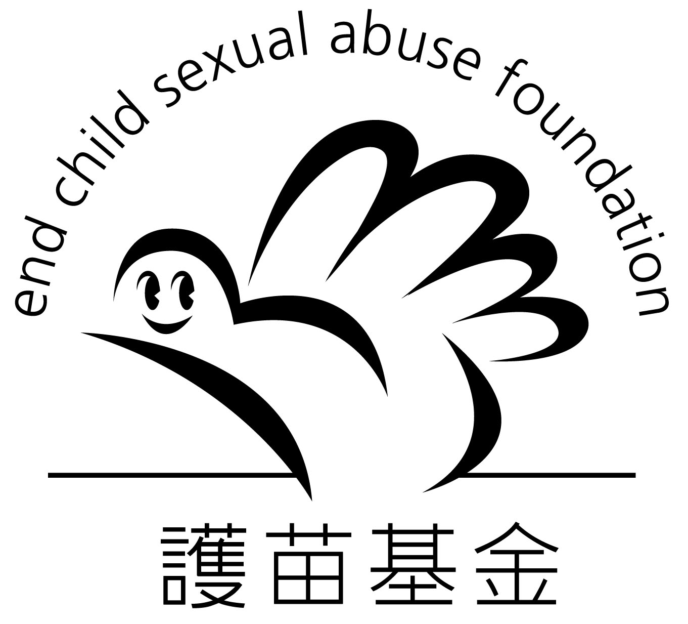

信用咭捐款授權書(一次過)
(Credit Card One-off Donation Direct Debit Authorization)

捐款人資料 Donor’s Information
捐款人姓名Name of Donor: _(Mr / Ms)____________________________________________
地址 Address: _______________________________________________________________
電話 Tel: _______________________________ 傳真 Fax: ___________________________
電郵 Email: _____________________________ 日期 Date: __________________________

信用咭捐款授權書 (一次過) Credit Card One-off Donation Direct Debit Authorization
❑ Visa  萬事達MasterCard

信用咭持有人的名稱Name of Cardholder: _____________________________________________________

信用咭號碼Credit Card Number： |  | ___ ___ ___ ___ - ___ ___ ___ ___ - ___ ___ ___ ___ - ___ ___ ___ ___
信用咭有效至Valid Until: |  | ___ ___ 月Month / ___ ___ 年Year
捐款金額Donation Amount |  | 信用咭持有人簽署 Signature of Cardholder
❑ | 港幣HK$ 50 | 簽名必需與閣下之信用卡簽名完全相同  Please sign your name as recorded on your Credit Card Account
❑ | 港幣HK$ 100
❑ | 其他 Others HK$ ______________

請填妥捐款表格後，郵寄至香港九龍石硤尾南山邨南泰樓地下1-12號『護苗基金』收 或
傳真至2889-9923 。謝謝。

Please return this form to ECSAF by mail (Address: Unit 1-12, G/F, Nam Tai House, Nam Shan Estate, Shek Kip Mei, Kowloon, Hong Kong) OR by Fax: 2889-9923. Thank you.

『護苗基金』感謝您的支持! Thank you so much for your support!
查詢電話: 2889-9922 網址: www.ecsaf.org

* * *

