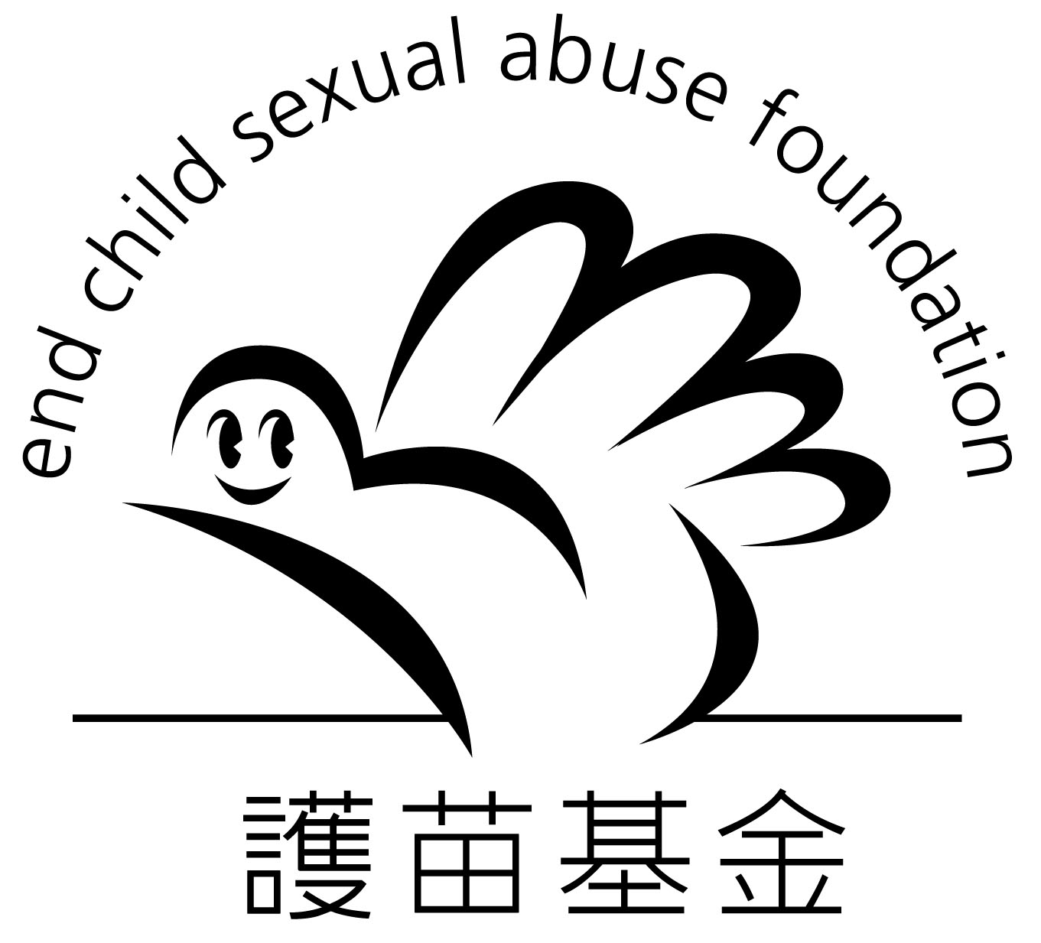

信用咭捐款授權書 (每月捐款計劃)
(Credit Card Monthly Donation Direct Debit Authorization)

捐款人資料 Donor’s Information
捐款人姓名Name of Donor: _(Mr / Ms)____________________________________________
地址 Address: _______________________________________________________________
電話 Tel: _______________________________ 傳真 Fax: ___________________________
電郵 Email: _____________________________ 日期 Date: __________________________

信用咭每月捐款授權書 Credit Card Monthly Donation Direct Debit Authorization Form
❑ Visa  萬事達MasterCard

信用咭持有人的名稱Name of Cardholder: _____________________________________________________
信用咭號碼Credit Card Number： |  | ___ ___ ___ ___ - ___ ___ ___ ___ - ___ ___ ___ ___ - ___ ___ ___ ___
信用咭有效至Valid Until: |  | ___ ___ 月Month / ___ ___ 年Year
每月捐款金額Monthly Donation Amount |  | 信用咭持有人簽署 Signature of Cardholder
❑ | 港幣HK$ 50 | 簽名必需與閣下之信用卡簽名完全相同  Please sign your name as recorded on your Credit Card Account
❑ | 港幣HK$ 100
❑ | 其他 Others HK$ ______________

請填妥捐款表格後，郵寄至香港九龍石硤尾南山邨南泰樓地下1-12號『護苗基金』收 或
傳真至2889-9923 。謝謝。
Please return this form to ECSAF by mail (Address: Unit 1-12, G/F, Nam Tai House, Nam Shan Estate, Shek Kip Mei, Kowloon, Hong Kong) OR by Fax: 2889-9923. Thank you.

本會將按月從以上信用咭戶口收取捐款，直至捐助者另行通知。收據將於每年四月份寄出。
Donation will be debited automatically from your credit card account monthly until your further notification. Receipt will be sent in April of each year.

『護苗基金』感謝您的支持! Thank you so much for your support!
查詢電話: 2889-9922 網址: www.ecsaf.org

* * *

